ALFIDO TECH DIGITAL MARKETING
INTERNSHIP
TASK 1 – REPORT
Submitted By – Vanshika Diyundi
Course – Bachelor of Computer Applications (BCA)
Organisation – Alfido Tech
Internship Domain – Digital Marketing
Task Number : 1

OBJECTIVE
The main objective of this task was to design an attractive social media poster that promotes alfido tech internship opportunities.

CONTENT USED
The poster included:
1)Attractive Headline
2)Company Logo
3)Key benefits
4)Internship Domains
5)Call to action

LEARNING OUTCOME
This assignment provided valuable practical knowledge to digital marketing. It help me to understand how visual content influences audience and how branding elements are contributed to create a professional identity .

Screenshots
Screenshot 1
Canva editing workspace
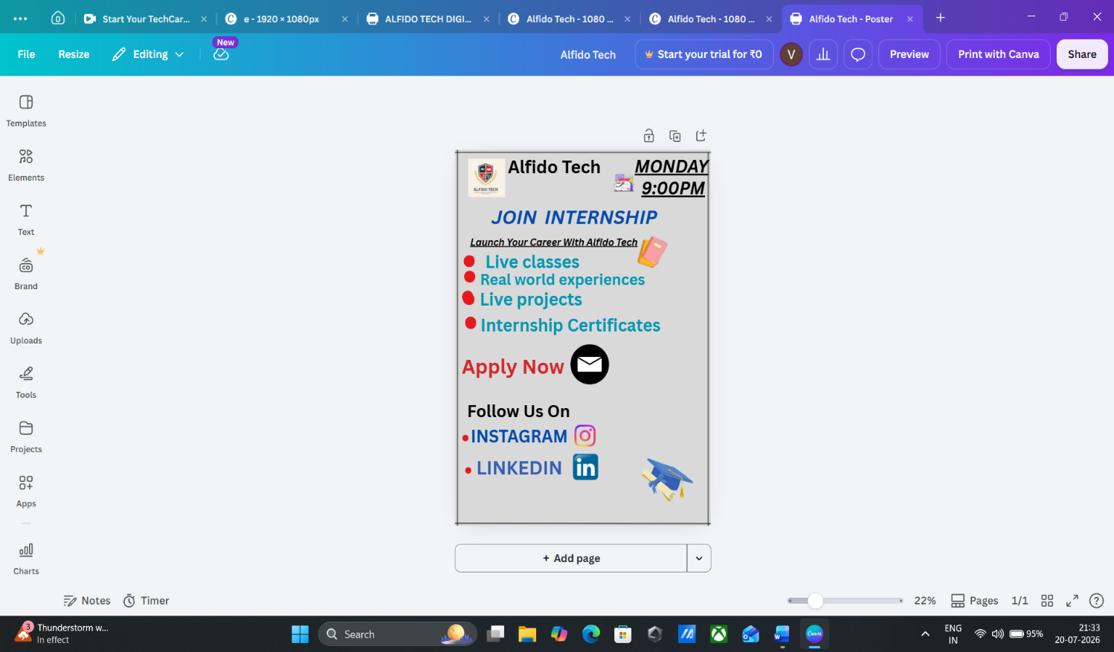

SCREENSHOT 2
Final Poster Design
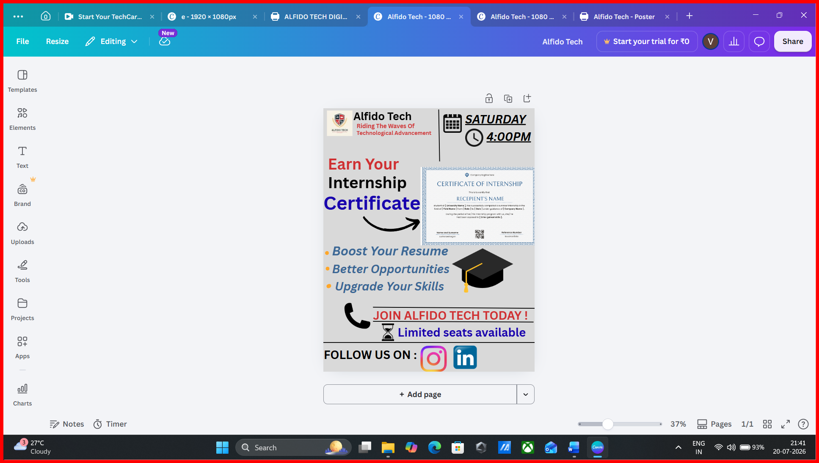

Google Drive Link
https://drive.google.com/file/d/1dQJUjig39nBFNbMy0DjdXjEHcnLltQtC/view?usp=drivesdk

Conclusion
Designing this social media poster was a valuable learning experience during my digital marketing internship at Alfido Tech . It also help me to apply theoretical concepts to a practical project improving my creativity and communication skills.

